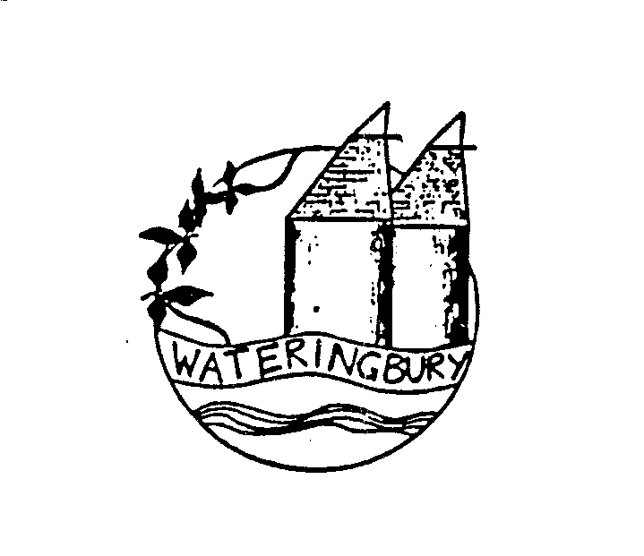
Wateringbury Local History Society and
Rapport Housing & Care
Invite you to the
unveiling of a blue plaque for
Augustus Leney
at The Orpines
Saturday 17th September at 11am
and afterwards to have a cup of tea or coffee and view the Meadow View Court show flat and communal facilities
The History Society’s next talk is in the Village Hall at 8pm on Wednesday 21st September when Barbara Stevens’ topic is My year as a Journalist
Join the Society for 2022/23 for £15 (8 talks plus other events)
or come as a visitor £5 per talk

